Ideation Phase Brainstorm & Idea Prioritization

Template

|  |  |
| --- | --- |
| Date | 24.09.2022 |
| Team ID | PNT2022TMID41917 |
| Project Name | Smart Solution for Railways |
| Maximum Marks | 4 Marks |

**Step-1: Team Gathering, Collaboration and Select the Problem Statement**

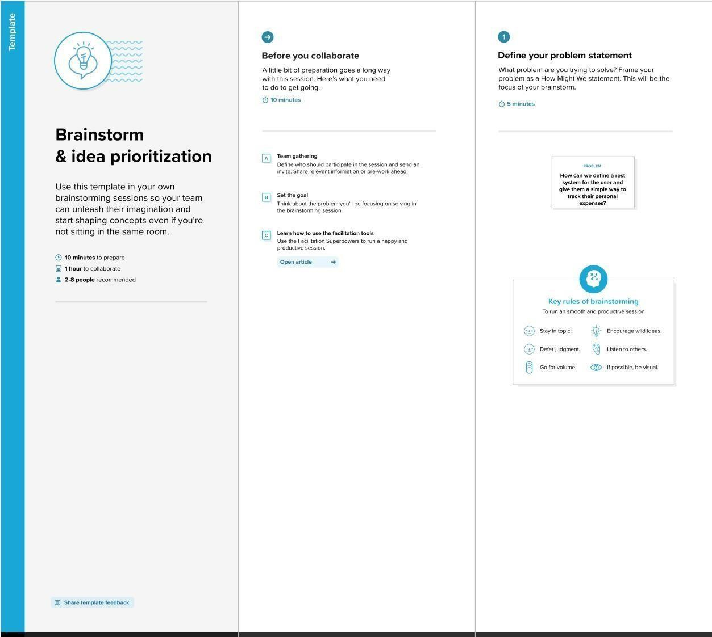

Step-2: Brainstorm, Idea Listing and Grouping

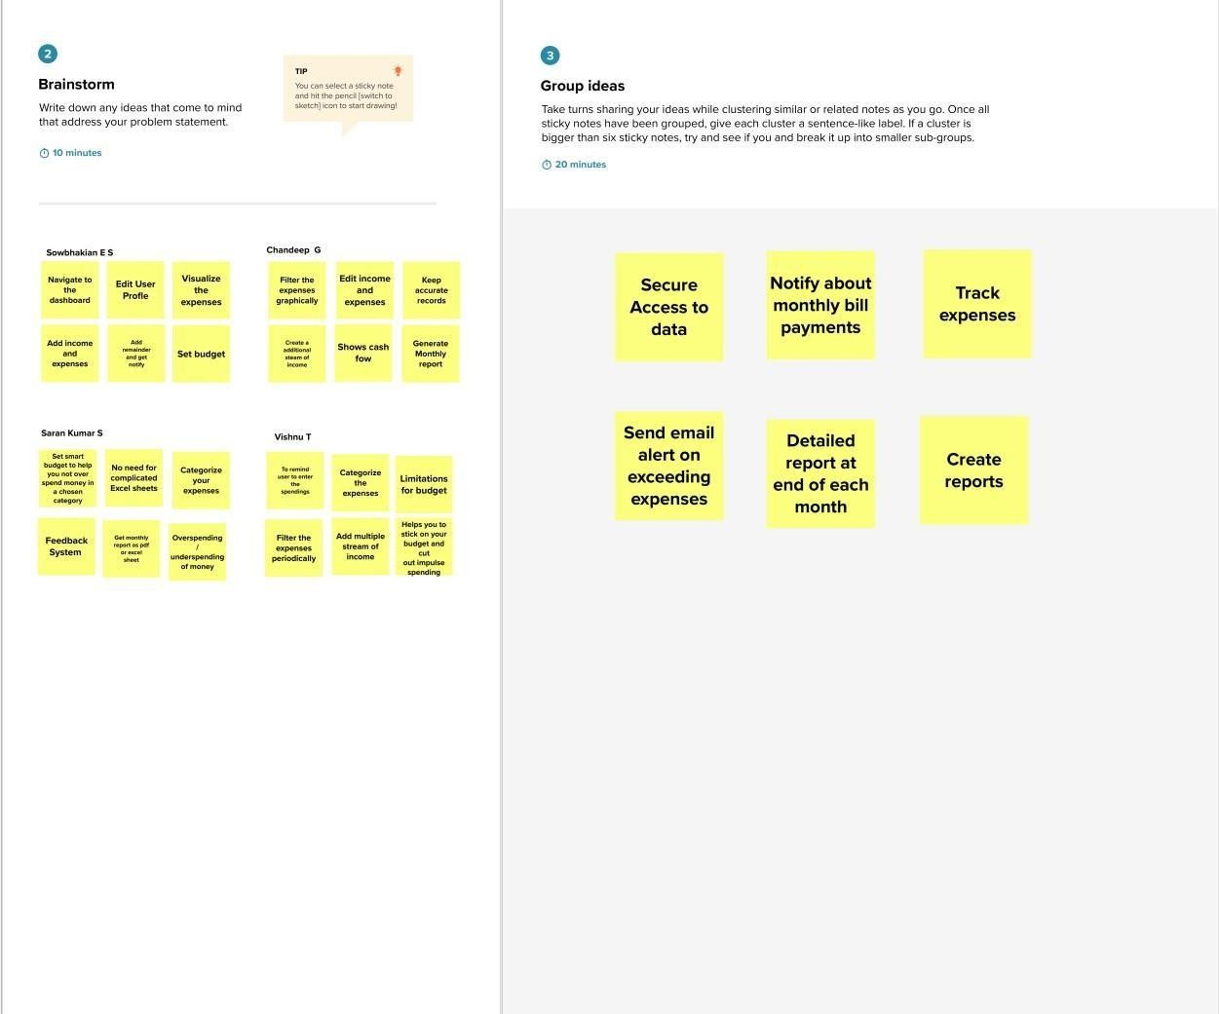

Step-3: Idea Prioritization

